**NNS Lab 4 - Answer Sheet**

Routing

Student Name: Sander

Student Surname: Hansen

Student Number: 10995080

Operating System: Ubuntu 14.04

Task 1.

Transformed graph plots.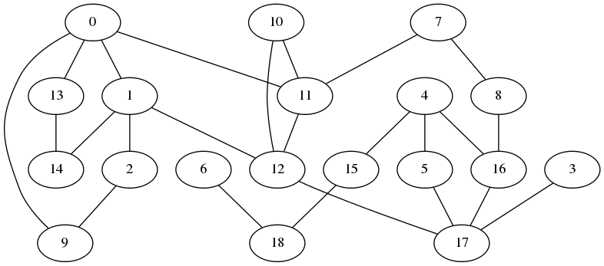

Task 2.

1) Shortest distance is; 2098587 meters. We came across 6 nodes. The number 6 includes the start and end node.

Write down the number of nodes in the shortest path

2) Adeliade1, Adelaide2, Melbourne2, Sydney2, Sydney1, Brisbane1

Write down the name of nodes in the shortest path

3) Marked with red in the included png (next page)

Identify the shortest path in the plots

Task 3.

1) 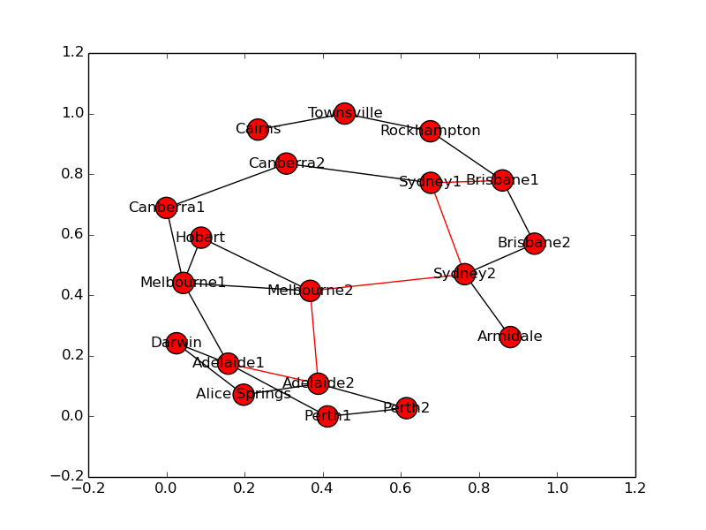The diameter is 6104677 meter

Write down the diameter of the network

2) The question in the assignment seems to ask something different; the nodes in the path of the diameter; Darwin, Adelaide1, Adelaide2, Melbourne2, Sydney2, Sydney1, Brisbane1, Rockhampton, Townsville, Cairns, my program does not find any other shortest paths.

Write down all the shortest paths equal to the diameter of the network

3) 1039 (assuming 1 and 6 from assignment 1)

Write down the number.

Task 4.

1) I assume that by 12 and 17 you are meaning 12 and 17 we calculated in assignment 1; which are Melbourne2 and Sydney2. Yes it does affect the diameter, it wil increase by 10 meters.

2)